Quarterly Report – Public Page

Date of Report: 4th Quarterly Report, September 27, 2024
Contract Number: 693JK32310013POTA
Prepared for: Government Agency: DOT and Co-funders
Project Title: Tank Foundation and Floor Designs and Best Practices for Improved Corrosion Control
Prepared by: Pipeline Research Council International (PRCI), Inc.
Contact Information: Janie Norton, jnorton@prci.org 703-205-1600 ext: 105
For quarterly period ending: September 30, 2024

1: Items Completed During this Quarterly Period:

Item # | Task # | Activity/Deliverable | Title | Federal Cost | Cost Share
8 | 4 | 4th quarterly status report & project management |  | $11,618 | $2,905

2: Items Not-Completed During this Quarterly Period:

Item # | Task # | Activity/Deliverable | Title | Federal Cost | Cost Share
1 | 1 | Kick-off web meeting with all stakeholders | Meeting minutes and a Summary of the Literature Review to be included in the  quarterly report | $34,863 | $8,716
3 | 2 | Facilitated Meetings/Data Mining of Operator-Industry Tank Designs, Corrosion Prevention, Monitoring and Leak Detection. | Summary of the industry tank designs and corrosion prevention and Leak detection and Release Prevention performance will be included in the quarterly report | $68,277 | $17,069
5 | 3 | Research on Release Prevention and Leak Detection Practices and Equipment | Summary of Findings On Leak Detection and Release Prevention to be included in the quarterly report | $43,572 | $10,893
7 | 4 | Developing Guidance on Best Practices for Sealing Tank Bottoms to Prevent Water and Foreign Material in Single and Multibottom Tanks. | Summary Report of Findings on Best Practices For Sealing Tanks to be included in the quarterly report. | $36,276 | $9,069

3: Project Financial Tracking During this Quarterly Period:

Note that this chart reflects Federal share only:

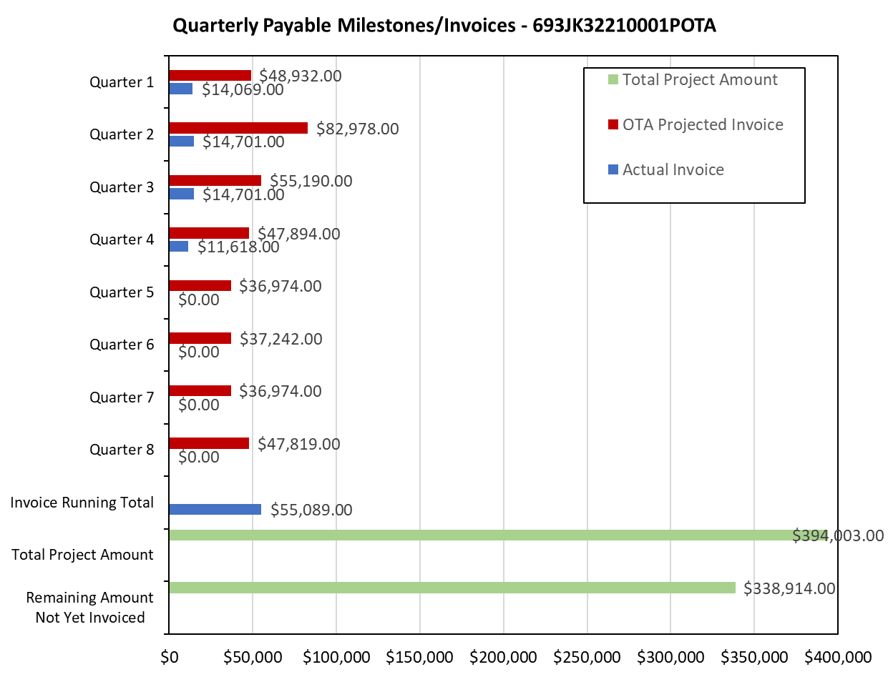

4: Project Technical Status –

Task 1 - Literature Review and Evaluation of Industry Practice - 95% Complete – Draft report comments received and being addressed.
Task 2 - Facilitated Meetings/Data Mining of Operator-Industry Tank Designs, Corrosion Prevention, Monitoring and Leak Detection –75% Complete-Two surveys issued-surveys received-compilation and statistical analysis report in progress -deep dive facilitated meetings will follow.
Task 3 – Research on Release Prevention and Leak Detection Practices and Equipment initiated.

5: Project Schedule –

The project is behind schedule due to an initial delay in contracting. Mears will commit additional and sufficient resources in the fourth Quarter to complete Task 1, 2,3 and 4 by year end.

